Kickstart report

Given historical data provided there seems to be a correlation between project success and a number of factors including funding, category and execution dates:

1. There is high correlation between high funding and success rate with all successful projects being funded 17-fold on average vs goal with an average of 100 USD funding per investor.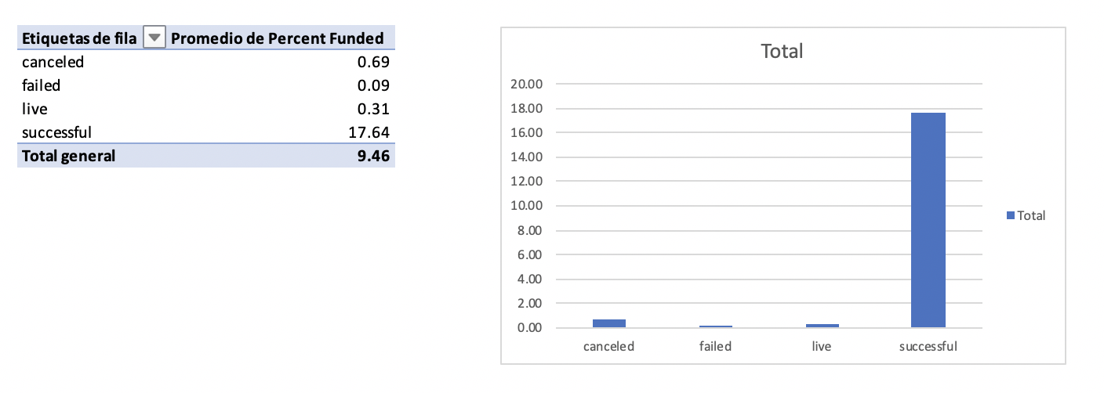
2. Project category also shows a strong correlation with success with theater projects being the most successful followed by music and film & video: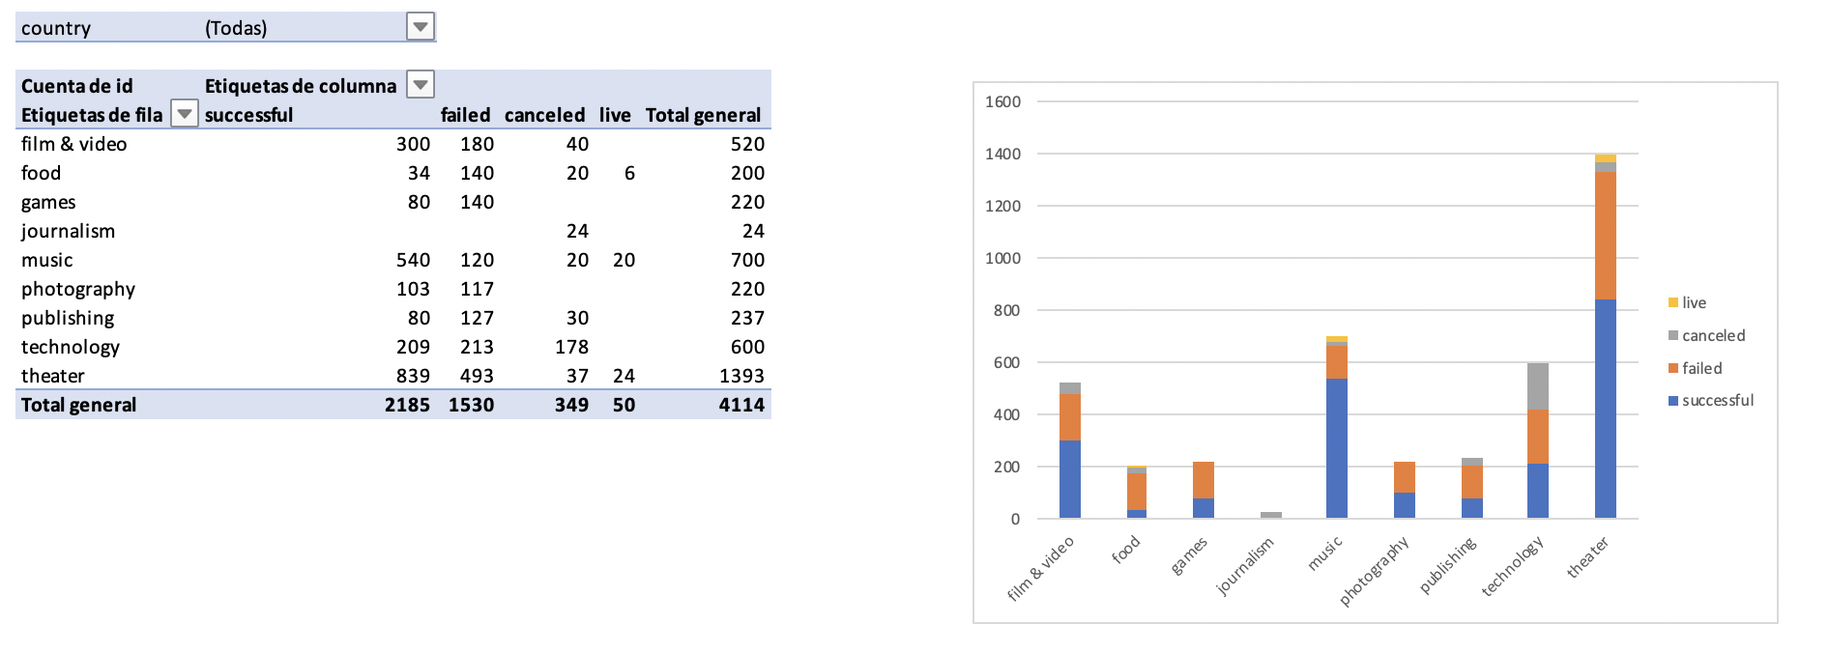
3. When we break down by sub category further correlations are revealed, here we see that plays inside the theater parent category are the most successful projects in absolute terms, also interesting facts, all rock and documentary projects have been successful, there are also other categories with 100% success rate like classic music and electronic music in spite of being small in absolute terms: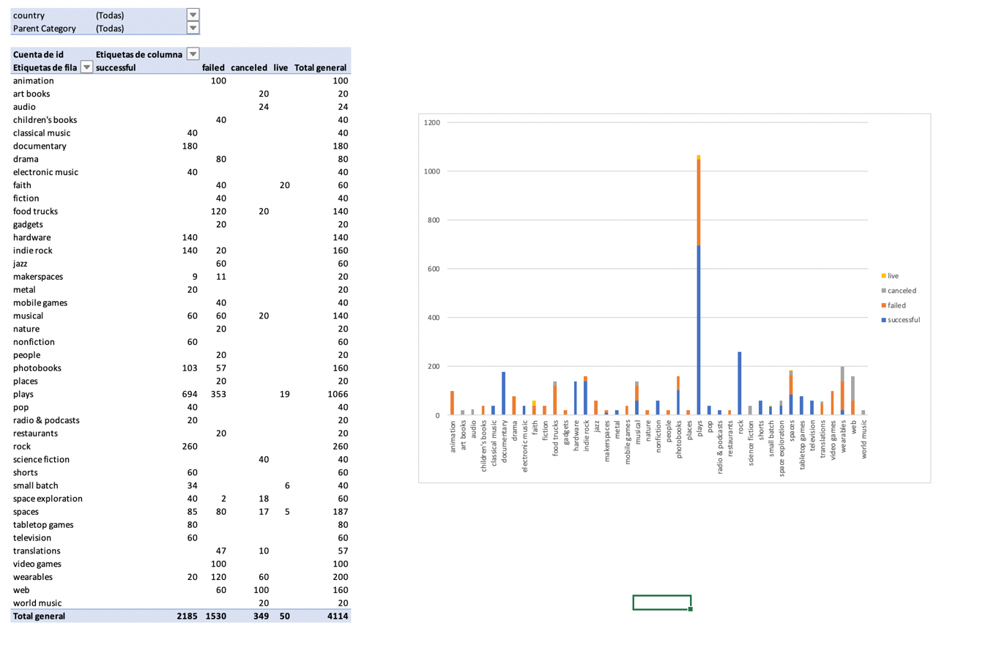
4. There is no strong correlation between execution time and project success, in a yearly basis we see more successful projects around 2015, but only because the absolute amount of projects grows as well: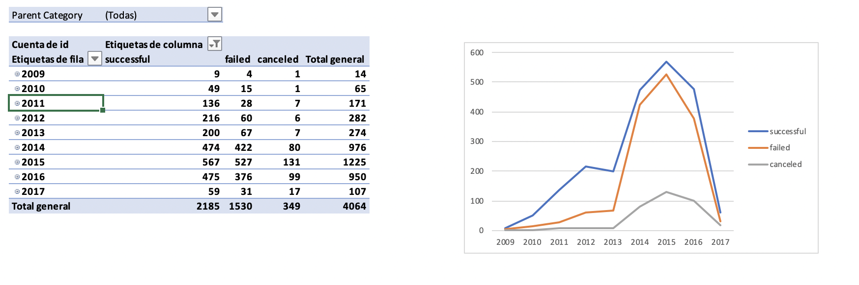

With the year factor left out there is however an interesting stational effect only considering the month of the year, where we see more succesfull projects stated in mid-year and less in years end: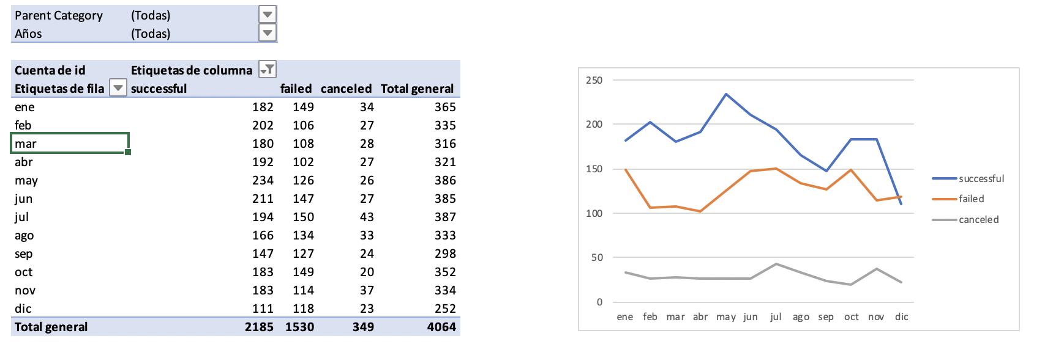

Based however in this specific data set we cannot know any objective metric of success, this is more of a demi binary indicator, only letting us know if the project was successful or not, but it would be very interesting if we could know what is the basis for saying a project was successful. We would need apart from goal and actual budget the expenses incurred and also the income that was generated, this way we could know how much profitable a project was and we could have a visual for ranking the most profitable projects to do further analysis on root causes.